Day 4 — AI Agents & Production Applications
1. Lab Objectives
By the end of this lab, you will be able to:
- Build an AI application using Semantic Kernel.
- Build an AI agent using LangChain.
- Build a multi-agent workflow using LangGraph.
- Implement agent routing and tool calling.
- Implement confidence-based escalation and Human-in-the-Loop.
- Connect agents to Azure AI Foundry.
- Deploy the application to Azure.
- Configure secure access using Managed Identity.
- Monitor the deployed application.
2. Scenario
You will build a Remittance Processing Assistant.
The application receives a remittance document and processes it through multiple AI agents.
User
│
▼
Supervisor Agent
│
├── Ingestion Agent
│
├── Remittance Validation Agent
│
├── Matching Agent
│
└── Smart Matching Agent
│
▼
HITL Review
│
▼
Final Result
This follows the multi-agent architecture in the provided reference lab.
3. Prerequisites
Ensure you have:
Resource | Purpose
Azure Subscription | Azure resources
Azure AI Foundry Project | AI application
GPT deployment | LLM
Windows/Linux VM | Development
VS Code | Coding
Python 3.10+ | Application
Git | Source control
Azure CLI | Deployment
Your reference lab also requires Python 3.10+, pip and Git.
Part 1 — Environment Setup

Step 1 — Create the Project
Open VS Code → Terminal.
Create the project:
mkdir Day4-MultiAgent
cd Day4-MultiAgent

python -m venv .venv
source .venv/bin/activate
Verify:
python --version
git --version
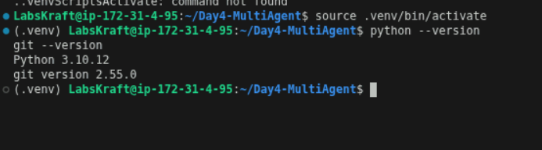
Expected:
Python 3.10+
Git version ...

Step 2 — Install Required Frameworks
Create:
requirements.txt
Add:
semantic-kernel
langchain
langchain-openai
langgraph
azure-identity
azure-ai-projects
python-dotenv
pydantic
fastapi
uvicorn
Install:
pip install -r requirements.txt
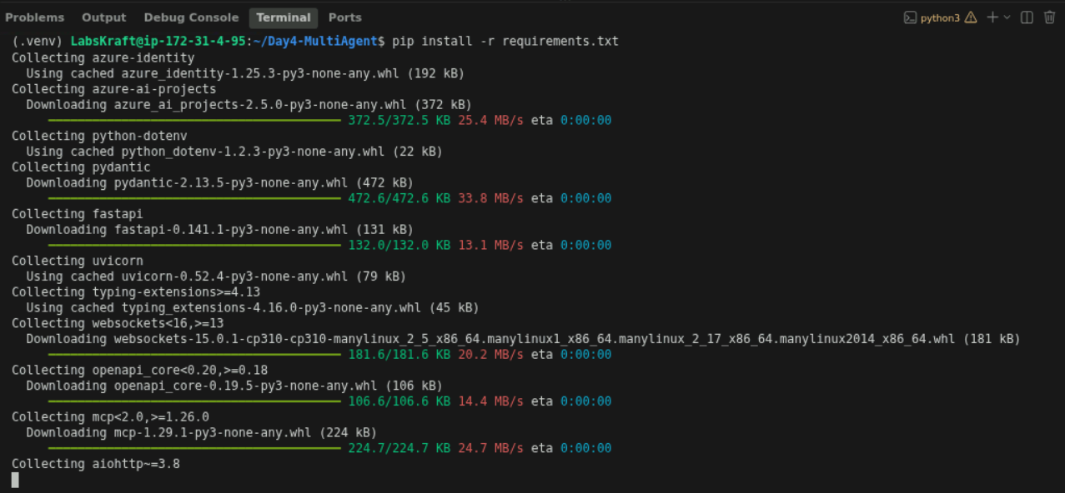
The reference lab uses LangGraph, LangChain OpenAI, Azure Identity, Azure AI Projects, dotenv and Pydantic.
Note: Framework APIs change over time. If your instructor provides pinned package versions, use those versions for the lab.

Part 2 — Connect to Azure AI Foundry

Step 3 — Configure Azure Credentials
In Azure AI Foundry:
Project → Settings → Endpoints and keys
Record the required endpoint/deployment information.
The reference lab uses the Azure endpoint, API key, deployment name and API version from the Foundry project.
Create:
.env
Add:
AZURE_OPENAI_ENDPOINT=<your-endpoint>
AZURE_OPENAI_API_KEY=<your-key>
AZURE_OPENAI_DEPLOYMENT_NAME=<your-deployment>
AZURE_OPENAI_API_VERSION=<your-api-version>
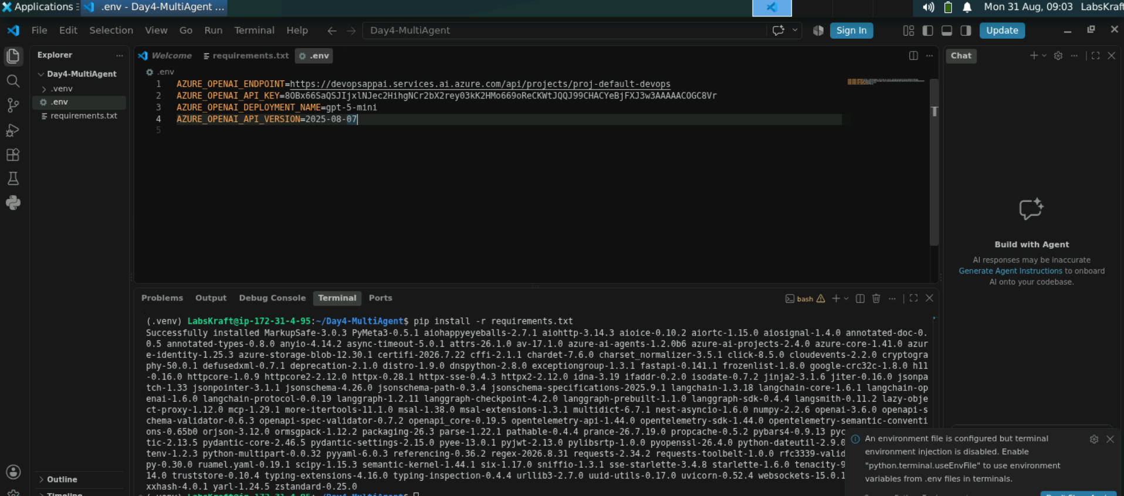
Do not commit .env to Git.
Create:
.gitignore
Add:
.env
.venv/
__pycache__/

Part 3 — Semantic Kernel

Step 4 — Build a Semantic Kernel Application
Semantic Kernel's Kernel manages AI services and plugins/functions. (Microsoft Learn)
Create:
semantic_kernel_app.py
Add:
import os
import asyncio
from dotenv import load_dotenv

from semantic_kernel import Kernel
from semantic_kernel.connectors.ai.open_ai import AzureChatCompletion

load_dotenv()

kernel = Kernel()

chat_service = AzureChatCompletion(
deployment_name=os.environ["AZURE_OPENAI_DEPLOYMENT_NAME"],
endpoint=os.environ["AZURE_OPENAI_ENDPOINT"],
api_key=os.environ["AZURE_OPENAI_API_KEY"],
)

kernel.add_service(chat_service)

async def main():
result = await kernel.invoke_prompt(
"Explain what an AI agent is in simple terms."
)

print("\nSemantic Kernel Response:\n")
print(result)

if __name__ == "__main__":
asyncio.run(main())
Run:
python semantic_kernel_app.py
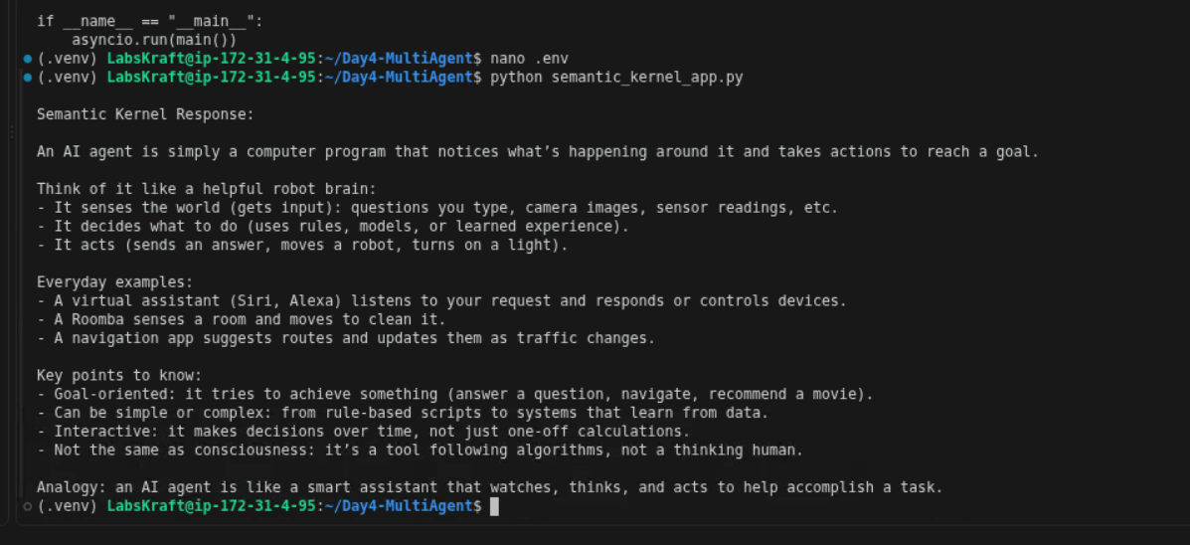

Expected Result
Semantic Kernel Response:

An AI agent is an application that uses an LLM...

Checkpoint
You have successfully:
- Connected Semantic Kernel to Azure GPT.
- Created a Kernel.
- Invoked an LLM prompt.
Semantic Kernel's Python documentation shows the Kernel as the central component and supports adding Azure chat-completion services and plugins. (Microsoft Learn)

Part 4 — Semantic Kernel Function

Step 5 — Create a Business Function
Create:
semantic_tools.py
Add:
from semantic_kernel.functions import kernel_function

class RemittancePlugin:

@kernel_function(
name="lookup_invoice",
description="Look up an invoice amount using its invoice ID."
)
def lookup_invoice(self, invoice_id: str) -> str:

invoices = {
"INV-1001": 5000,
"INV-1002": 7500,
"INV-1003": 3250
}

amount = invoices.get(invoice_id)

if amount is None:
return f"Invoice {invoice_id} was not found."

return f"Invoice {invoice_id}: ${amount:.2f}"
Now update semantic_kernel_app.py:
from semantic_tools import RemittancePlugin

kernel.add_plugin(
RemittancePlugin(),
plugin_name="Remittance"
)
Test the function:
result = await kernel.invoke(
kernel.plugins["Remittance"]["lookup_invoice"],
invoice_id="INV-1001"
)

print(result)
Expected:
Invoice INV-1001: $5000.00
Checkpoint: Semantic Kernel is now being used for LLM + plugin/function execution, not just prompting.

Part 5 — LangChain Agent

Step 6 — Build a LangChain Agent
LangChain's current Python agent API uses create_agent, with tools supplied to the agent. (Docs by LangChain)
Create:
langchain_agent.py
Add:
import os
from dotenv import load_dotenv

from langchain.agents import create_agent
from langchain_openai import AzureChatOpenAI
from langchain.tools import tool

load_dotenv()

model = AzureChatOpenAI(
azure_endpoint=os.environ["AZURE_OPENAI_ENDPOINT"],
api_key=os.environ["AZURE_OPENAI_API_KEY"],
azure_deployment=os.environ["AZURE_OPENAI_DEPLOYMENT_NAME"],
api_version=os.environ["AZURE_OPENAI_API_VERSION"],
temperature=0
)

@tool
def lookup_invoice(invoice_id: str) -> str:
"""Look up an invoice amount."""

invoices = {
"INV-1001": 5000,
"INV-1002": 7500,
"INV-1003": 3250
}

amount = invoices.get(invoice_id)

if amount is None:
return "Invoice not found."

return f"{invoice_id}: ${amount:.2f}"

agent = create_agent(
model,
tools=[lookup_invoice],
system_prompt=(
"You are a remittance processing assistant. "
"Use the invoice tool when invoice information is required."
)
)

result = agent.invoke({
"messages": [
{
"role": "user",
"content": "What is the amount of invoice INV-1001?"
}
]
})

print(result["messages"][-1].content)
Run:
python langchain_agent.py
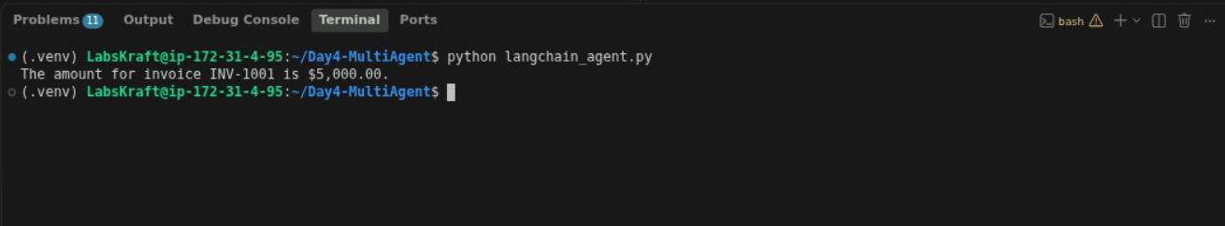

Expected Result
The agent should use lookup_invoice and return the invoice amount.
LangChain tools are callable functions that an agent can choose to invoke based on the task. (Docs by LangChain)

Part 6 — LangGraph Multi-Agent Orchestration

Step 7 — Define Agent State
LangGraph uses shared state to pass information between graph nodes. (Docs by LangChain)
Create:
state.py
Add:
from typing import TypedDict

class RemittanceState(TypedDict, total=False):

document: str
payer: str
amount: float
invoices: list
matches: list

confidence: float
next_agent: str

requires_hitl: bool
approved: bool

error: str
final_result: str

Step 8 — Create Specialist Agents
Create:
agents.py
Add:
def supervisor_agent(state):

if not state.get("payer"):
return {"next_agent": "ingestion"}

if not state.get("matches"):
return {"next_agent": "matching"}

return {"next_agent": "complete"}

def ingestion_agent(state):

document = state["document"]

return {
"payer": "Contoso Ltd",
"amount": 15750.00,
"invoices": [
"INV-1001",
"INV-1002",
"INV-1003"
]
}

def matching_agent(state):

matches = [
{
"invoice": "INV-1001",
"status": "matched",
"confidence": 0.98
},
{
"invoice": "INV-1002",
"status": "matched",
"confidence": 0.96
},
{
"invoice": "INV-1003",
"status": "matched",
"confidence": 0.99
}
]

confidence = min(
item["confidence"]
for item in matches
)

return {
"matches": matches,
"confidence": confidence
}

def hitl_review(state):

print("\nHuman review required.")

decision = input(
"Approve transaction? (approve/reject): "
)

return {
"approved": decision.lower() == "approve"
}

def final_agent(state):

if state.get("approved") is False:
result = "Transaction rejected by human reviewer."

else:
result = (
f"Payer: {state.get('payer')}\n"
f"Amount: ${state.get('amount', 0):.2f}\n"
f"Confidence: {state.get('confidence', 0):.2f}"
)

return {
"final_result": result
}

Step 9 — Build the LangGraph
Create:
graph.py
Add:
from langgraph.graph import StateGraph, START, END

from state import RemittanceState
from agents import (
supervisor_agent,
ingestion_agent,
matching_agent,
hitl_review,
final_agent
)

def route_after_matching(state):

confidence = state.get("confidence", 0)

if confidence >= 0.85:
return "final"

return "hitl"

builder = StateGraph(RemittanceState)

builder.add_node(
"supervisor",
supervisor_agent
)

builder.add_node(
"ingestion",
ingestion_agent
)

builder.add_node(
"matching",
matching_agent
)

builder.add_node(
"hitl",
hitl_review
)

builder.add_node(
"final",
final_agent
)

builder.add_edge(
START,
"supervisor"
)

builder.add_edge(
"supervisor",
"ingestion"
)

builder.add_edge(
"ingestion",
"matching"
)

builder.add_conditional_edges(
"matching",
route_after_matching,
{
"final": "final",
"hitl": "hitl"
}
)

builder.add_edge(
"hitl",
"final"
)

builder.add_edge(
"final",
END
)

graph = builder.compile()
LangGraph's Graph API uses state, nodes, edges and conditional routing to build workflows. (Docs by LangChain)

Step 10 — Add End-to-End Execution
Create:
main.py
Add:
from graph import graph

document = """
Remittance Advice

Payer: Contoso Ltd

Payment Amount: $15,750

Invoices:
INV-1001
INV-1002
INV-1003
"""

initial_state = {
"document": document,
"requires_hitl": False,
"approved": True
}

result = graph.invoke(initial_state)

print("\n===================================")
print("MULTI-AGENT PROCESSING COMPLETE")
print("===================================")

print("\nPayer:")
print(result.get("payer"))

print("\nAmount:")
print(result.get("amount"))

print("\nConfidence:")
print(result.get("confidence"))

print("\nMatches:")
print(result.get("matches"))

print("\nFinal Result:")
print(result.get("final_result"))
Run:
python main.py
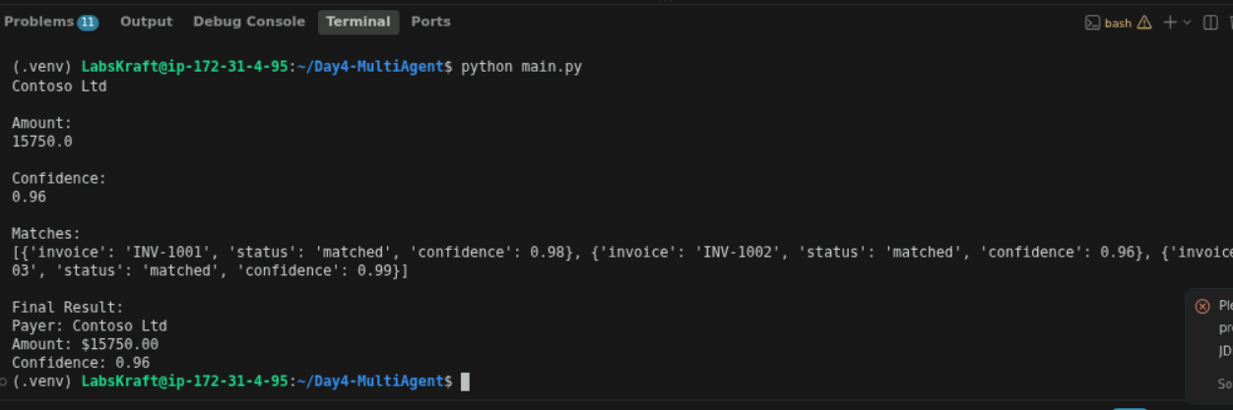

Expected Flow

START
↓
Supervisor
↓
Ingestion Agent
↓
Matching Agent
↓
Confidence Check
↓
Final Agent
↓
END
The reference lab similarly executes a Supervisor → specialist-agent pipeline and reports routing history, confidence and final results.

Part 7 — Human-in-the-Loop

Step 11 — Test Low-Confidence Processing
Modify the matching confidence:
confidence = 0.60
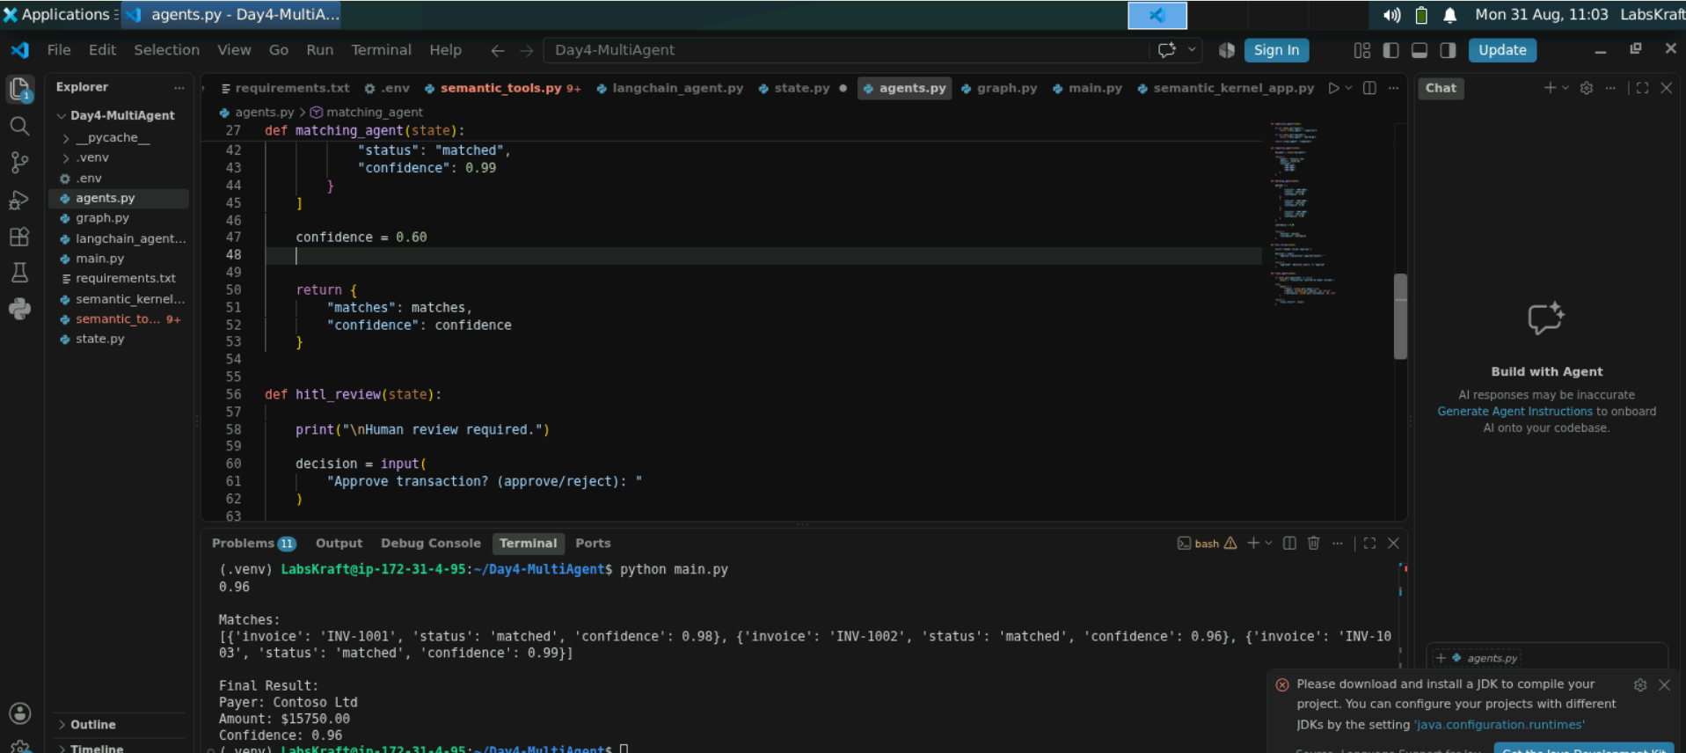
Run:
python main.py
Expected:
Human review required.

Approve transaction? (approve/reject):
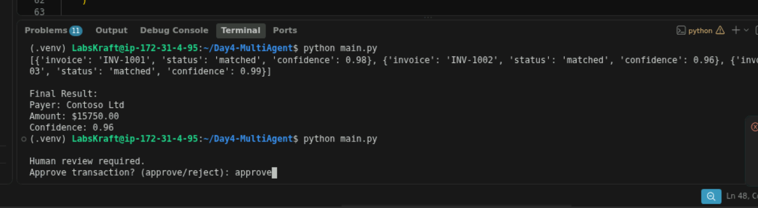
Enter:
approve
Verify that the workflow continues.
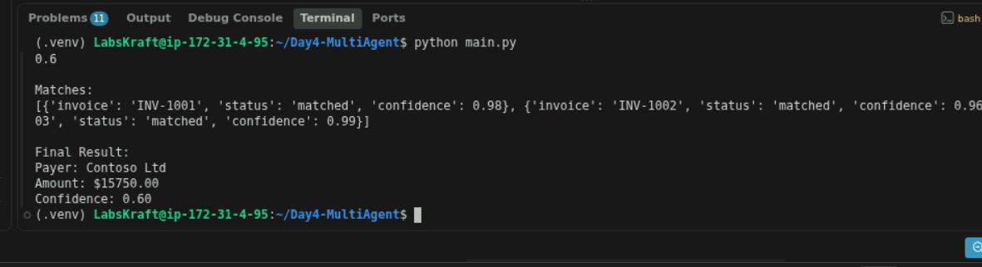
Now run again and enter:
reject
Expected:
Transaction rejected by human reviewer.
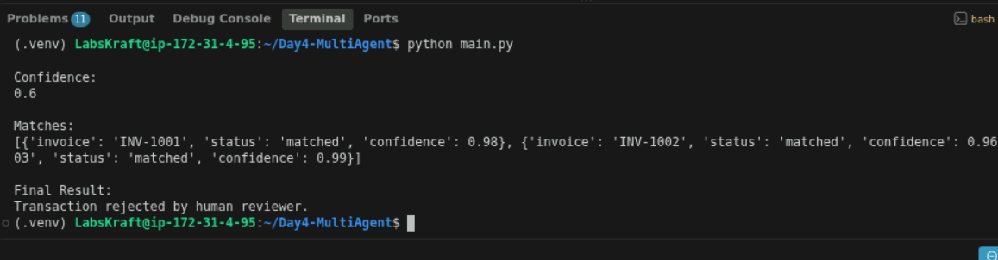
This demonstrates the same confidence-based escalation concept used in the provided reference lab, including HITL for lower-confidence results.

Part 8 — Retry and Error Handling

Step 12 — Add Retry/Error Handling
Update the graph so a failed operation can be retried.
For example, add a wrapper:
def safe_matching(state):

for attempt in range(3):

try:
return matching_agent(state)

except Exception as error:

if attempt == 2:
return {
"error": str(error)
}

return {}
Use:
builder.add_node(
"matching",
safe_matching
)
Test by temporarily introducing an error inside matching_agent().
Expected:
Attempt 1 → Failed
Attempt 2 → Retry
Attempt 3 → Retry
Final → Error Handler
Your uploaded reference lab uses a three-attempt retry policy with exponential backoff and a dedicated error handler.

Part 9 — Validation

Step 13 — Validate the Application
Create:
validate.py
Add:
from graph import graph

print("===================================")
print("DAY 4 VALIDATION")
print("===================================")

print("✓ Graph imported")
print("✓ Agents configured")
print("✓ State configured")
print("✓ Routing configured")
print("✓ HITL configured")
print("✓ LangGraph compiled")

test_state = {
"document": "Test remittance",
"approved": True
}

result = graph.invoke(test_state)

assert result.get("final_result") is not None

print("✓ End-to-end execution successful")
print("\nALL VALIDATIONS PASSED")
Run:
python validate.py
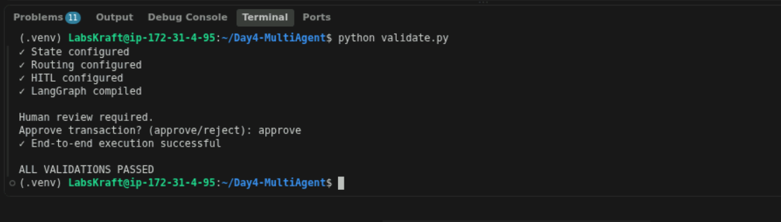
Expected:
✓ Graph imported
✓ Agents configured
✓ State configured
✓ Routing configured
✓ HITL configured
✓ LangGraph compiled
✓ End-to-end execution successful

ALL VALIDATIONS PASSED
Your reference lab uses a final validation stage with eight checks covering packages, state, tools, graph compilation, retry, routing and confidence thresholds.

Part 10 — Production Deployment

Step 14 — Deploy the Application to Azure
For the practical deployment exercise, expose the workflow through a small FastAPI application.
Create:
api.py
from fastapi import FastAPI
from pydantic import BaseModel

from graph import graph

app = FastAPI()

class Request(BaseModel):
document: str

@app.get("/")
def health():
return {
"status": "running",
"application": "Day4 Multi-Agent AI"
}

@app.post("/process")
def process(request: Request):

state = {
"document": request.document,
"approved": True
}

result = graph.invoke(state)

return {
"payer": result.get("payer"),
"amount": result.get("amount"),
"confidence": result.get("confidence"),
"matches": result.get("matches"),
"result": result.get("final_result")
}
Test locally:
uvicorn api:app --host 0.0.0.0 --port 8000
Open:
http://localhost:8000
You should see:
{
"status": "running",
"application": "Day4 Multi-Agent AI"
}
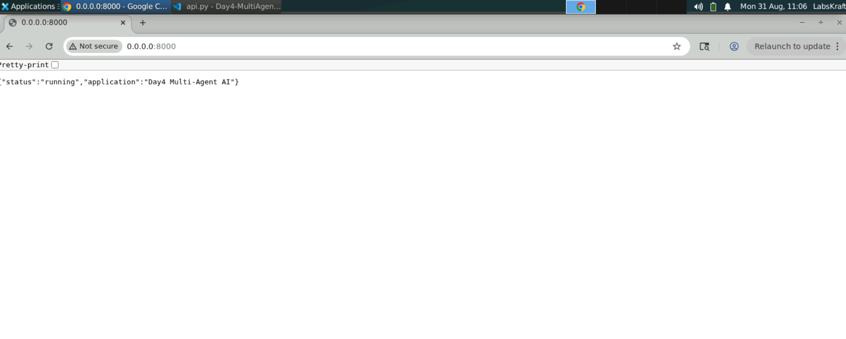
Azure App Service supports Python web applications and deployment through Azure CLI, VS Code or ZIP deployment. (Microsoft Learn)

